Screenshots Documentation – User Registration System
This document provides screenshots of the working user registration system along with clear explanations of each page and its functionality.

1. Registration Page (registration.html)
Screenshot: 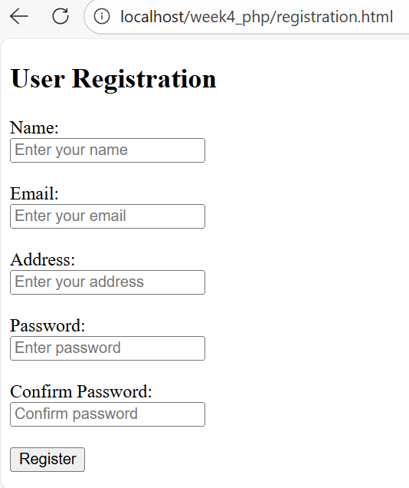
URL:
http://localhost/week4_php/registration.html
Explanation:
This page displays the user registration form. It allows users to enter their personal details, including Name, Email, Address, Password, and Confirm Password. The form uses the POST method to securely send user input to registration.php for processing. Placeholder text is used to guide the user on what information to enter in each field.

2. Validation Error Page
Screenshot: 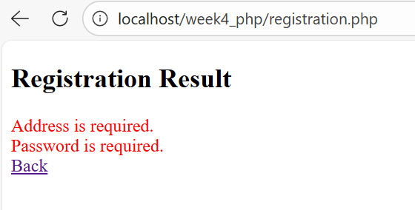
Explanation:
This screenshot shows the system response when invalid or incomplete data is submitted. Examples include empty fields, invalid email format, short passwords, or mismatched passwords. The PHP validation logic detects these errors and displays appropriate error messages, ensuring that incorrect data is not stored in the system.

3. Successful Registration Page
Screenshot:
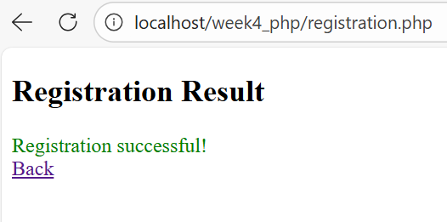
Explanation:
This page is displayed after the user submits valid registration details. A success message confirms that the registration has been completed successfully. At this stage, the user’s password is securely hashed, and all user details are saved into the JSON file.

4. users.json File
Screenshot:
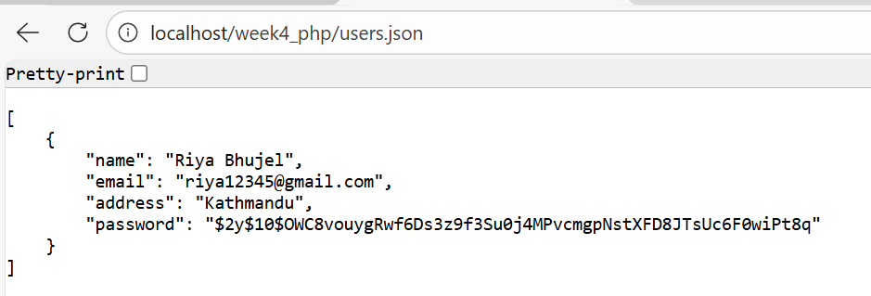
Explanation:
This screenshot shows the contents of the users.json file after a successful registration. The file stores user data in JSON format, including name, email, address, and a hashed password. This demonstrates that the system correctly reads from and writes to the JSON file for data persistence.

Conclusion
These screenshots confirm that the user registration system is fully functional. The system successfully handles user input, performs validation, stores data securely in a JSON file, and provides clear feedback to the user at each stage of the registration process.

